Model Documentation:
- Packaged Model Instructions
Please make sure to use the model in the same folder and same environment.

import pickle
import numpy as np
from pathlib import Path

# got the packaged model location
current_folder = Path(__file__).resolve().parent
model_path = current_folder / "final_model.pkl"

# open the packaged model
with open(model_path, "rb") as f:
pipeline = pickle.load(f)

The code about can help you not to run the entire model everytime.

- Data Preparation Summary
The raw data is stored in svmlight / libsvm format within one zip folder. It is stored in various files. After changing the format to flat file and merge the files together, we can clear na and drop the columns that only contains zero.
We also created a column is_high_risk for the model (if risk_score is higher than 0.3, is equal to 1(high risk)).

- Model Summary
The final model we chose is the Gradient Boosted Tree as it is very good at finding complex combinations of different system calls quickly. Our dataset is heavily unbalanced because around 90% of the files are high-risk. To fix this, we calculated a special weight for the data and added it to the .fit() step. We also split the data into a 70% Training, 15% Validation, and 15% Testing ratio. We used stratified splitting to make sure that the low-risk case were spread out evenly across all three groups.

From the picture below, both precision and recall in High Risk is over 90%.
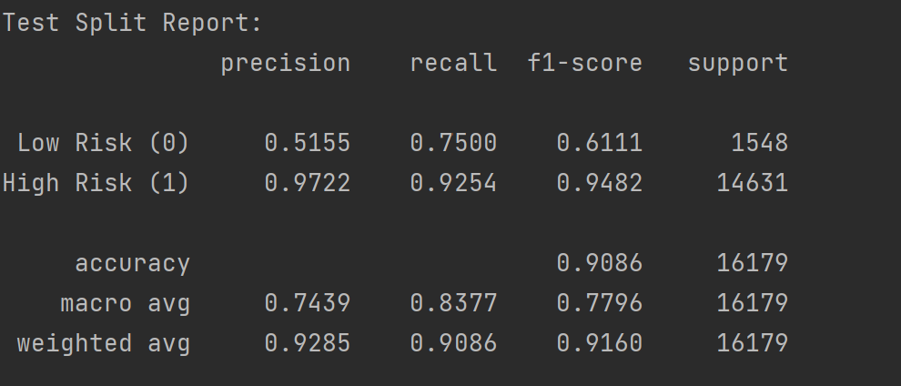

The picture below shows the top 15 features that the model uses to make decisions. We used a method called permutation importance on the validation data to find these.
